
PB1/CSQP/1222/B 08-DEC-2022
PREBOARD EXAMINATION - I (2022-2023)
Subject: Computer Science  Grade: XII |  | Max. Marks: 70  Time: 3 hours
General Instructions:
1. This question paper contains five sections – A , B , C , D and E. Each section is compulsory.
2. Section A has 18 questions of 1 mark each.
3. Section B contains 7 very short answer type questions of 2 mark each.
4. Section C contains 5 short answer type questions of 3 mark each.
5. Section D has 3 long answer type questions of 5 mark each.
6. Section E has 2 questions carrying 4 marks each. One internal choice is given in Q35 against part c.
7. All programming questions to be answered using Python Programming language only.
8. This Question paper has 11 pages.
 | SECTION A
1 | State True or False:-  “Positional arguments can be in any order.” |  | 1
2 | What type of objects can be used as keys in dictionaries? |  | 1
3 | What will be the output of the following program  test = {1:'A', 2:'B', 3:'C'}  del test[1]  test[1] = 'D'  del test[2]  print(len(test))  - 2  - 1  - 0  - Error |  | 1
4 | Consider the given expression:  True and True and not True or True and not False  Which of the following will be correct output if the given expression is evaluated?  - True  - False  - NONE  - NULL |  | 1
5 | What will be the output of the following python code:  a = "preboard exam"  a = a.split('a')  b = a[0] + "-" + a[1] + "-" + a[2]  print (b,end='%')  a. prebo-rd ex-m  b. prebo-ard ex-m%  c. prebo-rd ex-m%  d. prebo-ard ex-m |  | 1
6 | Manya wants to open an already created file “Society.dat ” for adding more information. In which mode should Manya open the file to perform the task.  - wb  - rb  - ab  - a |  | 1
7 | Which constraint allows null value and no duplicate values  - Group by  - Null  - Primary key  - Unique |  | 1
8 | Harish created a table Employee with the columns Empno,Ename, Salary and insert some rows into it. Later he added a column “bonus” and he wants to put “NULL” for all rows.Which SQL command is used for this.  - UPDATE  - INSERT  - ALTER  - ADD |  | 1
9 | Which of the following statement(s) would give an error after executing the following code:  X='P','R','E','B','O','A','R','D' # Statement 1  Y= ("A","B","C") # Statement 2  Z= X+Y # Statement 3  X[5]=Y[1] # Statement 4  X[2]+=2 # Statement 5  - Statement 3 and 5  - Statement 4 and 5  - Statement 5  - Statement 1,4 and 5 |  | 1
10 | Fill in the blank:  An alternate key is a _________, which is not the primary key of the table.  - Candidate key  - Primary key  - Alternate key  - Foreign key |  | 1
11 | tell() is a method of:  a. pickle module  b. csv module  c. file object  d. seek() |  | 1
12 | Which operator is used for searching null value  - Isnull  - Is  - nvl |  | 1
13 | Which protocol is used for downloading and uploading files  - STMP  - POP  - FTP  - IRC |  | 1
14 | What will the following expression be evaluated to in Python:  print(27 % 7 // 3 ** 2)  - 0  - 1  - Runtime Error  - 3 |  | 1
15 | function cannot be used with string type data?  a) min() b) max() c) count() d) sum() |  | 1
16 | In context of Python - Database connectivity, the function fetchmany() is a method of which object?  a) connection b) database c) cursor d) query |  | 1
17 | Assertion(A) – A stack is a linear data structure, that stores the elements in first in first out order.  Reasoning(R) – New element is added at one end and element is removed from that end only .  - Both A and B are true and R is the correct explanation for A  - Both A and B are true and R is not the correct explanation for A  - A is true but R is false  - A is false but R is true |  | 1
18 | Assertion(A) – COUNT() function ignores distinct  Reasoning(R) – Distinct ignores duplicate values.  - Both A and B are true and R is the correct explanation for A  - Both A and B are true and R is not the correct explanation for A  - A is true but R is false  - A is false but R is true |  | 1
 | SECTION B
19 | Rewrite the following code in python after removing all syntax error(s). Underline each correction done in the code.  250 = Number  WHILE Number<=1000:  if Number=>750  print (Number)  Number=Number+100  else  print( Number*2)  Number=Number+50 |  | 2
20 | Explain Bandwidth and Data transfer rate, also specify units for Bandwidth and Data transfer rate.  OR  State any 2 advantages of radio wave communication |  | 2
21 | - Given the Python string declaration:  Msg="PREBOARD 2023"  Write the output of : print(Msg[:3]+Msg[-4:])  - Write the output of the following code given below:  A=[1,2,3,4,5,6,7,8,9]  B=A.pop(5)  C=A.pop()  D=A.pop(-1)  print(B,C,D,A,sep=”#”) |  | 2
22 | Differentiate between equijoin and natural join with examples. |  | 2
23 | - Write the full forms of the following:-  - SMTP ii) VoIP  - State the function of Repeater |  | 2
24 | Predict the output of the Python code given below:-  code=1000  Rate=100  DD=1  def Getcode (C,R):  global code  global Rate  global DD  code = C;  Rate = R;  def Update (change,D):  global Rate  global code  global DD  Rate+=change;  DD = D;  def Status ():  print("Date : " ,DD)  print(code,Rate,sep="#")  Getcode (1324, 350)  Getcode (1435, 250)  Update (50, 28)  Status ()  Update (-25, 26)  Status ()  OR  Predict the output of the Python code given below:-  Ino=100  Iname="None"  Price=100  def Assign(I,Name,P):  global Ino  global Iname  global Price  Ino+=I;  Iname=Name  Price=P;  def Raise(P):  global Price  Price +=P;  def Reduce(P):  global Price  Price -=P;  def Disp():  print(Ino,Iname,Price,sep=":")  Assign (1,"Pen",95)  Raise(10)  Disp()  Assign(2,"Pencil",55)  Reduce(5)  Disp() |  | 2
25 | Differentiate between DDL and DML commands in SQL. Give an example for each.  OR  Name any four aggregate functions in SQL and also specify two aggregate functions that works on all data types. |  | 2
 | SECTION C
26 | Consider the following tables – StudentInfo 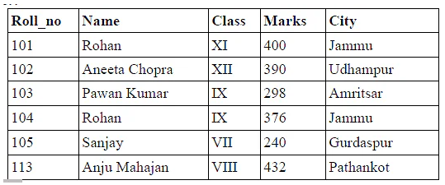  - What will be the degree and cardinality  b) Write the output of the queries i) to iv) based on the table given below:  Table : EmpInfo  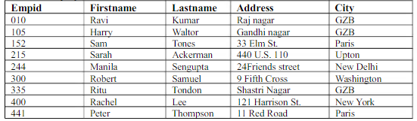  - SELECT FIRSTNAME, CITY FROM EmpInfo WHERE Address like ‘1%’ ORDER BY Empid DESC;  ii) SELECT FIRSTNAME, LASTNAME FROM EmpInfo WHERE City=’GZB’;  iii) SELECT FIRSTNAME,ADDRESS FROM EmpInfo WHERE CITY NOT IN  (‘GZB’,’PARIS’);  iv) SELECT COUNT(CITY),CITY FROM EmpInfo GROUP BY CITY; |  | 1+2
27 | Write a function COUNTWORD() in Python to read the contents from a text file ‘Mystory.txt’ and display all the words which contain vowels  OR  Write a function DISPLAYREV() in Python to read the contents from a text file ‘Poem.txt’ and display in reverse order.  Example: If the file content is as follows:  It rained yesterday.  It might rain today.  I wish it rains tomorrow too.  I love Rain.  The DISPLAYREV() function should display the output as:  .yadretsey deniar tI  .yadot niar thgim tI  .oot worromot sniar ti hsiw I  .niaR evol I |  | 3
28 | - Write outputs of SQL queries i) to iv) based on the relations SALES and LOCATION given below:-  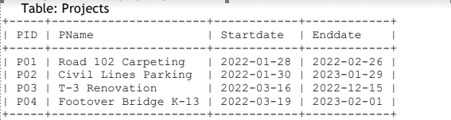  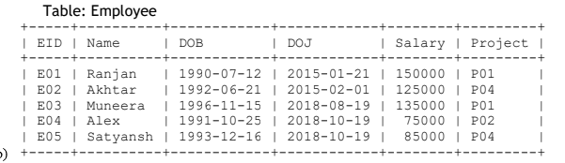  (i) select project, count(*) from employee group by project;  (ii) select pid, pname, eid, name from projects p, employee e where p.pid=e.project;  (iii) select min(startdate), max(startdate) from projects;  (iv) select avg(salary) from employee where doj between '2018-08-19' and '2018-08-31';  - Write an SQL statement to Create the database “MyDataBase”. |  | 3
29 | Write definition of a Method SHIFT(L) to shift all negative elements to left and positive elements to right without changing the order.  For example if the list is [10,-2.-8,5,3,-15,9,-1]  After shifting the list is [-2,-8,-15,-1,10,5,3,9] |  | 3
30 | A list contains following record of candidates those who are selected from different states:  [Candid_no,Candid_Name, Age, Marks_Recvd]  Write the following user defined functions to perform given operations on a stack named StkCandid:  - Push_ele(S) – To push objects containing name of candidate who are in the range of 15 to 30 to the stack  - Pop_ele() – To pop the elements from the stack and display them. Also display “Stack  Empty” where there are no elements in the stack.  For example:  If the list of Candidate details are:  [[‘M01’,’Mohan’,15,4500],[‘M02’,’Blake’,25,4800],[‘M03’,’Smith’,35,5500],[‘M04’,’Sales’,18,8000]]  The stack will contain  [‘M01’,’Mohan’,15,4500]  [‘M02’,’Blake’,25,4800]  [‘M04’,’Sales’,18,8000]  OR  Write a function push(Mitem) in Python where MItem is a dictionary containing the details of Mobile – {Mname : Model}  The function should push the names of mobiles into the stack STK whose Model is greater than 2000. Also display the count of elements pushed into the stack.  For example:  Movie={“Oppo”:1998, “Samasung”:2000 , “Iphone”:2022 , “Honor”:2021}  The stack should contain  Iphone  Honor  The output should be :  The count of elements in the stack is 2 |  | 3
 | SECTION D
31 | FutureTech Corporation, a Bihar based IT training and development company, is planning to set up training centers in various cities in the coming year. Their first center is coming up in Surajpur district. At Surajpur center, they are planning to have 3 different blocks - one for Admin, one for Training and one for Development. Each block has number of computers, which are required to be connected in a network for communication, data and resource sharing. As a network consultant of this company, you have to suggest the best network related solutions for them for issues/problems raised in question nos. (i) to (v), keeping in mind the distances between various blocks/locations and other given parameters.  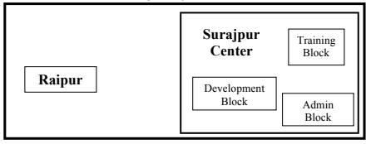  NO OF COMPUTERS IN EACH BLOCK  (i) Suggest the most appropriate block/location to house the SERVER in the Surajpur center (out of the 3 blocks) to get the best and effective connectivity. Justify your answer.  (ii) Suggest why should a firewall be installed at the Surajpur Center?  (iii) Suggest the best wired medium and draw the cable layout (Block to Block) to most efficiently connect various blocks within the Surajpur Center.  (iv) Suggest the placement of the following devices with appropriate reasons:  a) Switch/Hub b) Router  (v) Suggest the best possible way to provide wireless connectivity between Surajpur Center and CoimbatoreCenter. |  | 5
  Development to Admin | 28 M
  Development to Training | 105 M
  Admin to Training | 32 M
  Surajpur Campus to Coimbatore Campus | 340 KM
  Development | 90
  Admin | 40
  Training | 50
32 | - Write the output of the code given below:  def switchover(A,N,split):  for K in range(N):  if K<split:  A[K] += K;  else:  A[K]*= K;  def display(A,N):  for K in range(N):  if K%2== 0:  print(A[K],end="%")  else:  print(A[K])  H= [30, 40, 50, 20, 10, 5]  switchover(H, 6, 3)  display(H, 6)  - The code given below displays the following record in the table Product:  Pcode – integer  PName – string  Dateofpurchase – Date  Price – integer  Write the following missing statements to complete the code:  import mysql.connector  def sql_data():  con1=mysql.connector.connect(host="localhost",user="root", password="tiger", database="Inventory")  mycursor=_______________ #Statement 1  ____________________ #Statement 2  data=__________________ #Statement 3  for i in data:  print(i)  print()  Statement 1 – to form the cursor object  Statement 2 – to execute the query that extracts records of those products whose date of purchase is in the month of October.  Statement 3- to read the complete result of the query into the object named data, from the table Product in the database.  OR  - Predict the output of the code given below:  def repch(s):  k=''  for i in range(len(s)-1):  if i%2!=0 and s[i]!=s[i+1]:  k+='@';  elif s [i]==s[i+1]:  k+='!';  else:  k+=s[i]  return k  s="SUCCESS";  print("Original String=",s)  print("Changed string=",repch(s))  - The code given below inserts the following record in the table Flight:  Fno– integer  From – string (Starting point)  To– string (Destination Point)  Fare– float  Write the following missing statements to complete the code:  import mysql.connector  def sql_data():  con1=mysql.connector.cnnect(host="localhost",user="root", password="tiger", database="FlightInfo")  mycursor=_______________ #Statement 1  F=input(“Enter new starting point”)  T=input(“Enter new destination point”)  Q=”update flight set From=’{}’ ,To=’{}’ where Fno=’F101’ ”.format(F,T)  ____________________ #Statement 2  ____________________ #Statement 3  print(“Data updated successfully”)  Statement 1 – to form the cursor object  Statement 2 – to execute the command that updates the record in the table Flight.  Statement 3- to update the record permanently in the database. |  | 2+3
33 | What are the advantages of CSV file?  Write a program in python that defines and calls the following user defined functions:  - ADD() – To accept and add data of a music to a CSV file “Music.csv”. Each record consists of a list of field elements as MusicId , Mname , Type and Rating.  - DISPLAY() – To display the music whose rating is greater than 5.  OR  What is the function of in a writerows() in CSV file?  Write a program in python that defines and calls the following user defined functions:  - ADD() - To accept and add data of Employees to a CSV file “Payroll.csv”. Each record consists of a list of field elements as Empid , Ename , BasicPay,HRA  HRA is 5% of BasicPay.  - COUNT() – To count the number of employees who are getting the BasicPay in the range of 4000 to 8000. |  | 5
 | SECTION E
34 | Consider the table Purchase given below:  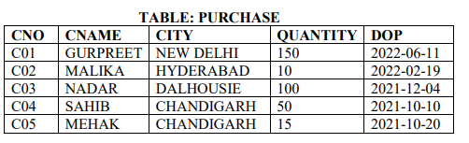  Based on the data given above answer the following questions:-  - Identify the most appropriate column, which can be considered as Primary key.  - If three columns are added and five rows are deleted from the table , what will be the new degree and cardinality of the above table?  - Write the statements to:  a. delete the rows those who purchased on 2022  b. Increase the Quantity of all purchase whose city is CHANDIGARH by 10.  OR (Option for part iii only)  iii) Write the statements to:  - Add a column Discount in the table with datatype as float  - Assign the value NULL to discount for all rows |  | 4
35 | Shivam has written a code and want to create a binary file Furniture.dat with fid, fname and fprice. As a Python expert, help him to complete the following code based on the requirement given above:  import _______ #Statement 1  def Add_data():  Fout=open("Furniture.dat",------) # Statement2  L=----------------------------------#statement3  ----------------------------------------# Statement4  Fout.close()  - Which module should be imported in the program? (Statement 1)  - Write the correct statement required to open file named Furniture.dat. (Statement 2)  - Write the Statement 3 to read the data from user.  - Write a statement to write data in the file Furniture.dat (Statement 4) |  | 4

***

